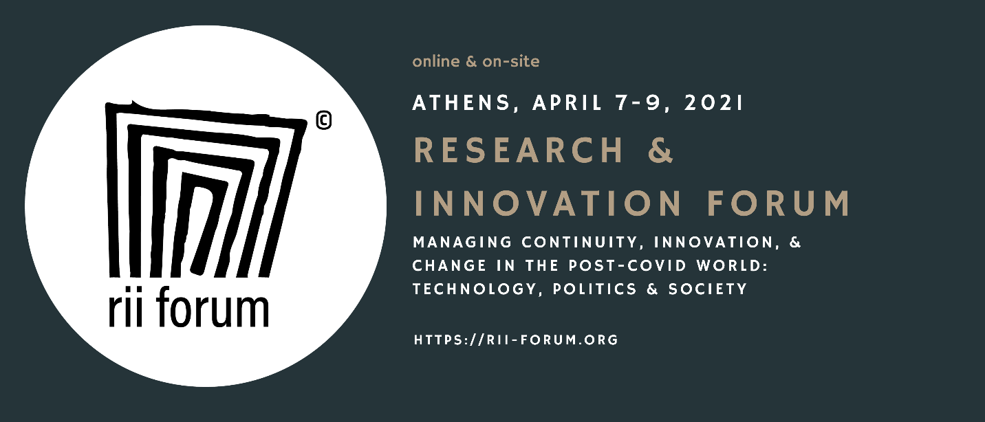
Rii Forum 2021
call for panel proposals
Deadline: October 5, 2021

Title of the panel:
max 80 characters

Short description of the panel
including the rationale, the objectives, key questions to be addressed (max 400 words)

The Conveners:
names, affiliations, email addresses

Send the proposal to the conference team at info@rii-forum.org

